JOB BOARD PLATFROM

A MINI PROJECT REPORT

*Submitted by*

Group/Team No: G7

**KHYATI, 2310990549**

**KRISH, 2310990550**

**KRISHNA,2310990551**

*in partial fulfillment for the award of the degree*

*of*

**BACHELOR OF ENGINEERING**

***in***

COMPUTER SCIENCE & ENGINEERING



**CHITKARA UNIVERSITY**

CHANDIGARH- PATIALA NATIONAL HIGHWAY

RAJPURA (PATIALA) PUNJAB-140401

DECEMBER 2023

TABLE OF CONTENTS

|  |  |  |
| --- | --- | --- |
| S.NO | SECTION | PAGE NO. |
| 1 | INTRODUCTION | 3 |
| 2 | PROBLEM STATEMENT | 4 |
| 3 | TECHNICAL DETAILS | 5-7 |
| 4 | KEY FEATURES | 8-9 |
| 5 | PROJECT ADVANTAGES | 10 |
| 6 | BONUS FEATURES | 11 |
| 7 | RESULT | 12 |
| 8 | CONCLUSION | 13 |

Introduction

Welcome to our Front End Engineering Project titled: **Job Board Platform** This project is a showcase of our skills in HTML and CSS, designed to present our professional information in an interactive and visually appealing manner. In today`s digital age, having an online presence is crucial, and what better way to stand out than by creating a personalized webpage that reflects your unique personality and qualifications.

In this project, we have utilized the fundamental building blocks of web development – **HTML (Hypertext Mark-up Language)** for structuring content and **CSS (Cascading Style Sheets)** for styling – to create a sleek and professional job platform. Whether you're a potential employer, client, or simply someone interested in getting to know us better, this webpage serves as a comprehensive snapshot of our qualifications, experiences, and skills.

Problem Statement

The current job search and recruitment process is inefficient and time-consuming, with job-seekers and employers facing challenges in finding and connecting with the right candidates or job opportunities. There is a lack of a comprehensive and user-friendly job board platform that effectively matches jobseekers with suitable jobs and provides employers with streamlined tools for posting, managing, and attracting qualified candidates.

This results in a frustrating and disjointed experience for both job-seekers and employers, leading to prolonged hiring processes, limited visibility of job opportunities, and missed potential matches. Hence, there is a need for a user-friendly and efficient job board platform that brings together job seekers and employers in one place.

This platform should simplify the job search process for job seekers, provide a convenient and effective way for employers to reach potential candidates, and enhance the overall experience for both parties involved. Therefore, there is a need for a robust and intuitive job board platform that addresses these pain points and revolutionizes the recruitment process, enhancing the efficiency and effectiveness of job search and talent acquisition.

Technical Details

The technical details for this project can be broadly classified into two categories, on basis of the code content. The HTML code we have created contains a variety of HTML elements. Here's a breakdown of the HTML elements used in the code:

**Document Structure Elements:**

* <!DOCTYPE html>: Declares the document type and version.
* <html>: The root element of the HTML document.
* <head>: Contains meta-information about the document, such as character encoding, viewport settings, title, and links to external resources.
* <meta>: Provides metadata about the document, including character encoding and viewport settings.
* <title>: Sets the title of the webpage that appears in the browser's title bar.
* <link>: Specifies an external CSS style sheet to be applied to the webpage.

**Body Content Elements:**

* <body>: Contains the visible content of the webpage.
* <div>: A container element used for grouping and styling various sections of the webpage.
* <h1>, <h2>, <h3>: Headings used to create section titles and subheadings.
* <p>: Paragraph elements for text content.
* <ul>: Unordered list element for creating lists.
* <li>: List item elements used within <ul> to create list items.
* <strong>: Used to indicate strong importance or emphasis within the text.
* <img>: Embeds an image in the webpage.

**Links and Anchors:**

* <a>: Anchor elements used for creating hyperlinks to external web pages or resources.

**HTML5 Structural Elements:**

* <header>, <main>, <section>, <article>, <aside>, <footer>: While not explicitly used in this code, these are HTML5 structural elements that are often used for organizing and semantically structuring the content of a webpage.

**Comments:**

<!-- ... -->: HTML comments used for adding explanatory notes within the code that are not visible in the rendered webpage. These HTML elements are used to structure and create the content of the webpage, define headings, paragraphs, lists, images, links, and other visual and structural elements. The combination of these elements forms the structure and content of the resume webpage.

The CSS code used in the project contains various technical components used to style a webpage. Here's a breakdown of the key technical components and their purposes:

Universal Selector (*): It selects all HTML elements on the page. The properties within this selector are used to reset padding, margin, and box-sizing for all elements to ensure a consistent layout.

.

**html and body:** These selectors style the HTML and body elements. The HTML element's font size is set to 20px , and the font family for the entire document is set to “Segoe UI." The background colour is set to black, and text colour to white.

**Common Styles:** These are general styles applied to img elements and links (a). It removes underlines from links and sets the text color to white.

**Class Selectors**: These selectors style elements with specific class names. For example, .description, .title, .item_preTitle, .item_title, .item_subtitle, etc., have various styles associated with them, including font sizes, colors, and margins.

**Layouts:** Styles for layout-related components, such as .container, which sets the maximum width, padding, and grid layout for the webpage's content. .profile, .group-1, .group-2, and .group-3 define layout-related styles for different sections of the webpage.

**Additional Styles:** Styles for various other sections of the webpage, such as Hobbies, Experience, Education, Expertise, Interests, Socials, and an hr element to create horizontal lines.

**Custom Variables (CSS Variables):** Custom properties defined using --variable-name syntax, like --primary-color and --text-color, are used to store and reuse color values throughout the stylesheet.

**CSS Flexbox:**

Flexbox is used in several places to control the layout of elements:

.profile_container uses flex properties to control the layout of elements within it, making them align horizontally.

.group-1 and .group-2 use flex properties to create a vertical layout with gaps between elements.

.intItems uses flex properties to create a flexible, wrap-around layout for interest elements.

The HTML elements are used to structure and create the content of the webpage, define headings, paragraphs, lists, images, links, and other visual and structural elements. The combination of these elements forms the structure and content of the resume webpage.

The technical components and selectors used in the CSS code to style the resume webpage help define the layout, typography, colours, and responsiveness of the webpage.

KEY FEATURES

The HTML and CSS code used in the project addresses the problem statement for creating a resume webpage by incorporating various key features to create an organized, visually appealing, and informative online resume. Here are the key features used in the code:

**HTML Features:**

**Semantic HTML Structure**: The use of semantic HTML elements such as <header>, <main>, <section>, <h1>, <h2>, <ul>, <li>, and others helps to create a well-structured and meaningful document outline, improving accessibility and SEO.

**Image Embedding**: The <img> element is used to embed a profile picture, making the webpage more personal and visually appealing.

**Hyperlinks**: <a> elements are used to create hyperlinks to the author's social media profiles and email, facilitating easy contact and exploration of additional information.

**Lists**: The use of <ul> and <li> elements is employed to create lists of interests and experiences, making the information easier to read and understand.

**CSS Features:**

**CSS Variables (Custom Properties)**: Custom CSS variables (e.g., --primary-color and --text-color) are defined in the: root selector, allowing for easy and consistent color theming throughout the stylesheet.

**CSS Resets**: The * selector is used to reset padding, margin, and box-sizing for all elements, ensuring a consistent starting point for styling.

**Responsive Design**: Media queries (@media) are used to adjust the layout and styling of elements for screens with a maximum width of 760px, making the webpage responsive and mobile-friendly.

**CSS Flexbox**: Flexbox is used to create flexible and responsive layouts within sections like the profile container, groups of interests, and education, making the design adaptive to different screen sizes.

**Class Selectors**: Class selectors (e.g., .profile, .title, .description) are used extensively to target specific elements and apply styles consistently across the webpage, ensuring a cohesive design.

**Font Styling**: Custom fonts from Google Fonts are imported and applied to elements for improved typography.

**Hover Effects**: Hover effects are implemented (e.g., changing text color on hover) to provide interactivity and visual feedback.

**Backgrounds and Margins**: Background colors, padding, and margins are used effectively to create visual separation between different sections of the resume.

These features collectively address the problem statement by creating a well-structured, visually appealing, and responsive online resume that effectively showcases the author's qualifications, interests, and contact information.

PROJECT ADVANTAGES

* a) User-friendly interface: A job board platform should have an intuitive and easy-to-use interface, allowing job-seekers to easily navigate through the platform and find relevant job listings.
* b) Application Management: The platform should facilitate the application process, allowing jobseekers to easily apply for jobs directly through the platform. It should also provide tools for employers to manage and track job applications efficiently.
* c) Job posting and management tools: The platform should offer employers a user-friendly dashboard where they can easily create, manage, and track job postings. It should also allow them to edit and update job listings as needed.
* d) Resume/CV creation and storage: Users should have the ability to create and upload their resumes or CVs, and the platform should provide storage options to securely store these documents so they can be easily accessed and submitted for job applications.
* e) Mobile compatibility: In today's mobile-driven world, it is essential for the job board platform to be mobile-friendly, allowing users to access and use the platform seamlessly on their smartphones or tablets.

BONUS FEATURES

* **Collaboration:** The project highlighted the importance of effective collaboration within the team. Each member brought their unique skills and perspectives to create a cohesive and well-executed webpage.
* **Web Development Proficiency:** Team members deepened their knowledge and skills in web development, particularly in HTML and CSS, which are essential technologies for creating professional websites.
* **Customization and Styling**: The team learned how to effectively use custom CSS properties, selectors, and third-party libraries to style and customize web content, giving the webpage a unique and professional look.
* **Problem Solving:** Throughout the project, the team encountered and resolved various technical challenges, strengthening their problem-solving skills in web development.
* **Continuous Learning:** Building the webpage served as a learning opportunity, encouraging team members to stay up-to-date with web design trends and technologies.
* **Portfolio Enhancement:** The completed project provided team members with a valuable addition to their portfolios, showcasing their web development skills and creativity to potential employers and collaborators.
* **Team Work:** The project work was distributed among all the three members of the team. Project involvement was as follows:

Krish: Designing of main page for the website, Search bar, Project report

Krishna: Chat feature, Login Portal, Webpage for Home offering multiple platforms , Employee Registration Form,

Khyati: Webpage for About Us and Contact us

Overall, the project was a valuable learning experience that allowed the team to apply their web development skills to create an effective online resume webpage while gaining insights into best practices, collaboration, and user-centered design.

RESULT

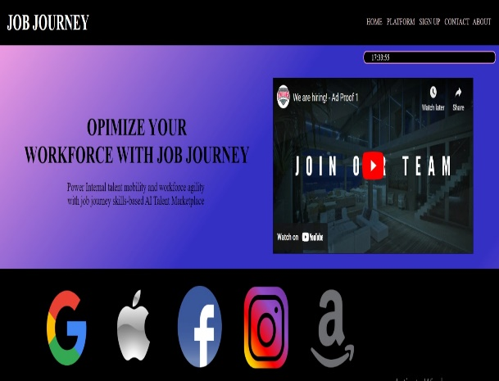 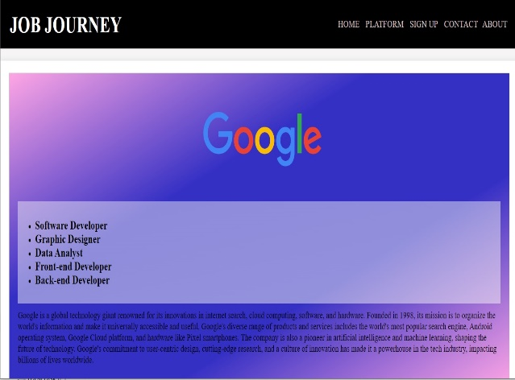

LANGUAGE USED: HTML STYLING USED: CSS

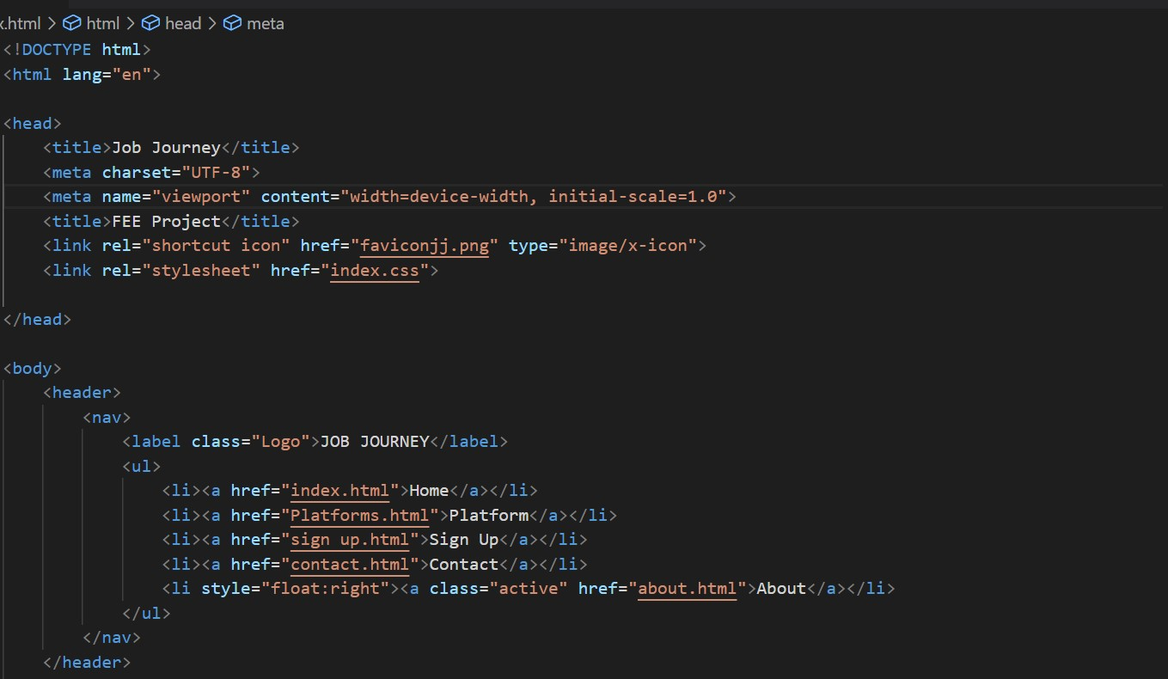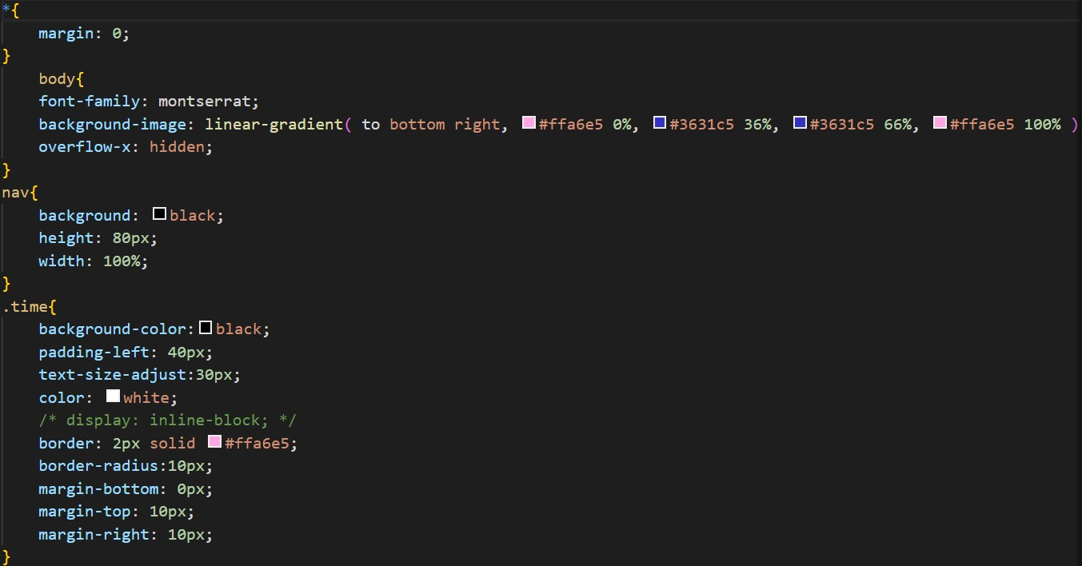

Conclusion

In conclusion, using online job forms in a project is a strategic and valuable approach to gather feedback, assess performance, and drive continuous improvement. The insights derived from survey results contribute significantly to informed decision-making, stakeholder engagement, and the overall success of the project.

The proposed system is a combination of the different activities of Job Seekers, Job Providers and e-Learner. The site is proposed to be one of the large commercial and informative website providing its services to all kinds of people. Major functionalities of the site include providing services to recruitment agencies, Software and Hardware development companies, job seekers and e-learners. In spite of having various features, few of the major features are services for job recruiters, job seekers and e-learners. To accomplish the above problems a project on “Online job searching” was developed with the following objectives:

1. To enhance the existing techniques for job searching.
2. To provide services to job seekers, job providers and e-learners

